WEEK 2:

**Exercise 1: Setting Up Junit**

Pom.xml:

<project xmlns="http://maven.apache.org/POM/4.0.0" xmlns:xsi="http://www.w3.org/2001/XMLSchema-instance" xsi:schemaLocation="http://maven.apache.org/POM/4.0.0 https://maven.apache.org/xsd/maven-4.0.0.xsd">

<modelVersion>4.0.0</modelVersion>

<groupId>com.example</groupId>

<artifactId>JUnitSetupExample</artifactId>

<version>0.0.1-SNAPSHOT</version>

<dependencies>

<!-- JUnit 4.13.2 Dependency -->

<dependency>

<groupId>junit</groupId>

<artifactId>junit</artifactId>

<version>4.13.2</version>

<scope>test</scope>

</dependency>

</dependencies>

</project>

Calculator.java

package math;

public class Calculator {

public int add(int a, int b) {

return a + b;

}

}

CalculatoreTest.java

package math;

import org.junit.Test;

import static org.junit.Assert.*assertEquals*;

public class CalculatorTest {

*@Test*

public void testAdd() {

Calculator calc = new Calculator();

int result = calc.add(5, 3);

*assertEquals*(8, result);

}

}

Output:

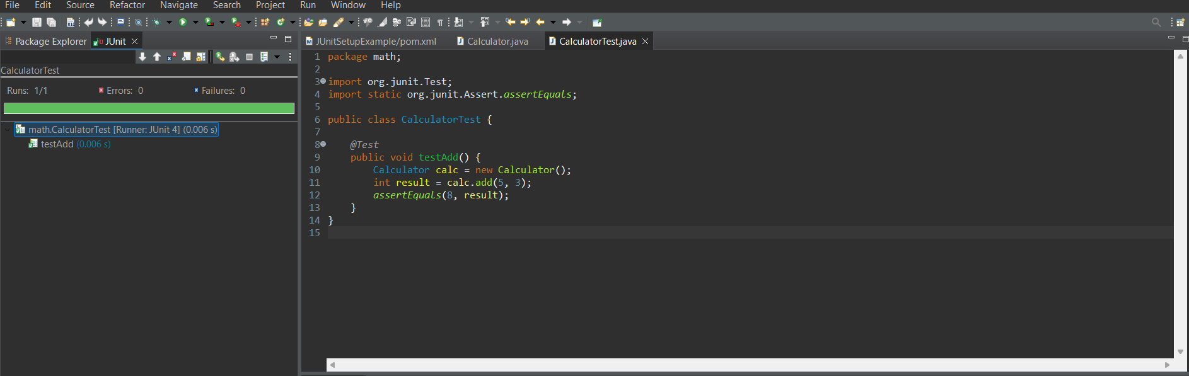

**Exercise 3: Assertions in Junit**

Pom.xml

<project xmlns="http://maven.apache.org/POM/4.0.0" xmlns:xsi="http://www.w3.org/2001/XMLSchema-instance" xsi:schemaLocation="http://maven.apache.org/POM/4.0.0 https://maven.apache.org/xsd/maven-4.0.0.xsd">

<modelVersion>4.0.0</modelVersion>

<groupId>com.example

</groupId>

<artifactId>JUnitAssertionsExample</artifactId>

<version>0.0.1-SNAPSHOT</version>

<dependencies>

<!-- JUnit 4 Dependency -->

<dependency>

<groupId>junit</groupId>

<artifactId>junit</artifactId>

<version>4.13.2</version>

<scope>test</scope>

</dependency>

</dependencies>

</project>

**AssertionTest.java**

package test;

import org.junit.Test;

import static org.junit.Assert.*;

public class AssertionsTest {

@Test

public void testAssertions() {

// Assert equals

assertEquals(5, 2 + 3);

// Assert true

assertTrue(5 > 3);

// Assert false

assertFalse(5 < 3);

// Assert null

assertNull(null);

// Assert not null

assertNotNull(new Object());

}

}

Output:

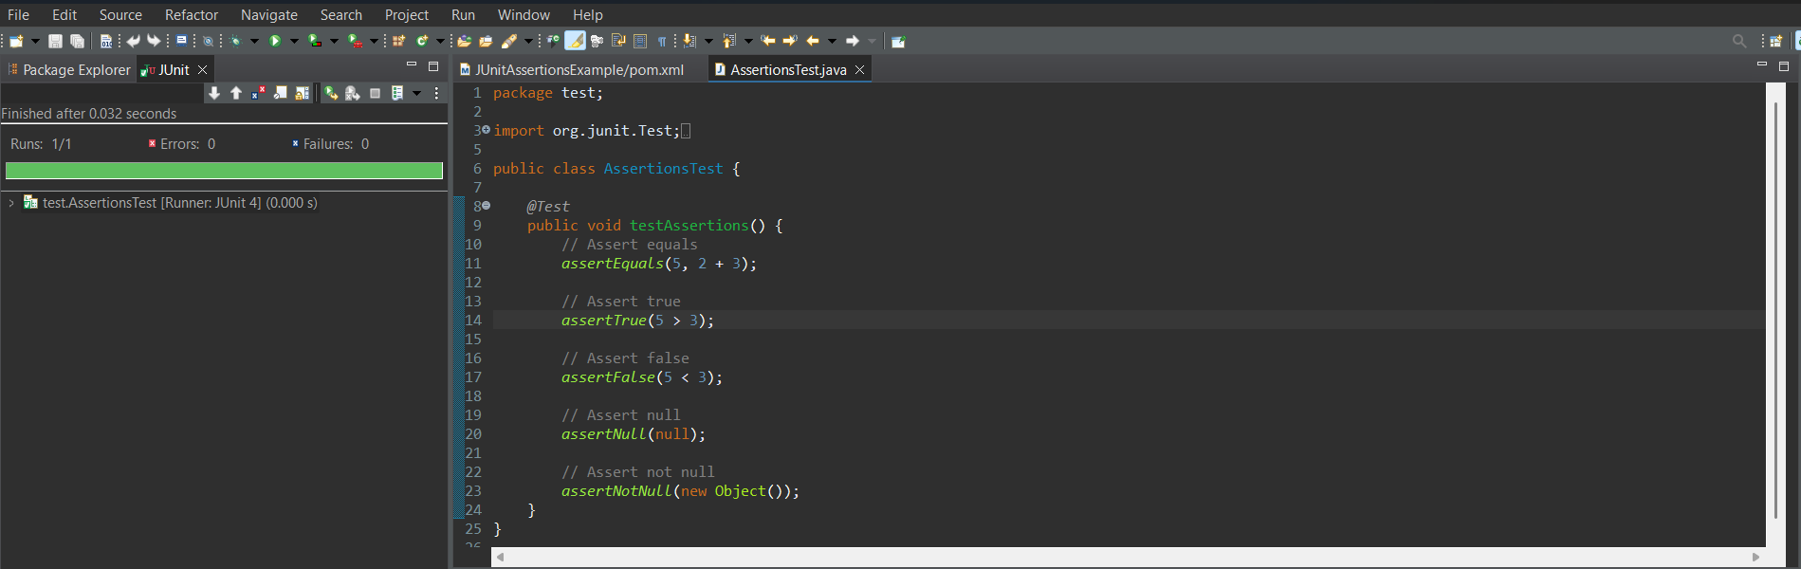

**Exercise 4: Arrange-Act-Assert (AAA) Pattern, Test Fixtures, Setup and Teardown Methods in Junit**

Pom.xml

<project xmlns="http://maven.apache.org/POM/4.0.0" xmlns:xsi="http://www.w3.org/2001/XMLSchema-instance" xsi:schemaLocation="http://maven.apache.org/POM/4.0.0 https://maven.apache.org/xsd/maven-4.0.0.xsd">

<modelVersion>4.0.0</modelVersion>

<groupId>com.example</groupId>

<artifactId>JUnitAAATest</artifactId>

<version>0.0.1-SNAPSHOT</version>

<dependencies>

<dependency>

<groupId>junit</groupId>

<artifactId>junit</artifactId>

<version>4.13.2</version>

<scope>test</scope>

</dependency>

</dependencies>

</project>

Calculator.java

package com.example;

public class Calculator {

public int add(int a, int b) {

return a + b;

}

public int multiply(int a, int b) {

return a * b;

}

}

CalculatorTest.java

package com.example;

import org.junit.After;

import org.junit.Before;

import org.junit.Test;

import static org.junit.Assert.*;

public class CalculatorTest {

private Calculator calculator;

// 🔧 Setup method - runs before each test

*@Before*

public void setUp() {

calculator = new Calculator(); // Arrange

System.***out***.println("Setup: Calculator initialized.");

}

// 🧹 Teardown method - runs after each test

*@After*

public void tearDown() {

System.***out***.println("Teardown: Test completed.");

}

*@Test*

public void testAddition() {

// Act

int result = calculator.add(2, 3);

// Assert

*assertEquals*(5, result);

}

*@Test*

public void testMultiplication() {

// Act

int result = calculator.multiply(4, 5);

// Assert

*assertEquals*(20, result);

}

}

Output:

